**Dvd 2** .- Simple present, , There is a…(singular) and there are some …(plural), Frequency adverbs: Subject + F.A. + Verb :EXCEPTION: Subject + to be + F.A.: **Every Day**, **Simple**, **Never**, **Often**(a menudo, con frecuencia), **Sometime** (occasionally), **Always**, **Usually**, **Rarely**(Seldom) //. “**Enough**”( it’s not sufficient) and “**Too**”-> Uncountable: **too much** + noun (it’s sufficient) countable: **too many** + noun and **too** + adjective (too full, too expensive), they are the opposite at enough, “**So**” when you want to emphasize something (you are so intelligent). PRESENT SIMPLE: Question form, Negative form Some and Any,. Making suggestions.

***There is a…(singular) and there are some …(plural)***

*Countable*

Singular verb: **A/an**

* There is **a** cd
* Is there a cd?
* there isn’t a cd

Plural verb: **Some/Any**

* Positive form: **Some:**
  + There are some cd’s
* Negative form and interrogative: **Any:**
  + Are there any cd’s?
  + There aren’t any cd’s

*Uncountable*

Singular verb: **Some/Any**

* Positive form: **Some:** 
  + ***There is some*** sugar
* Negative form and interrogative: **Any**:
  + ***There isn’t any*** sugar
  + Is there any sugar

Plural verb:

* Como son incontables no tienen plural

|  |
| --- |
| Resultado de imagen  <http://3.bp.blogspot.com/-wJ0J4Zi_bTo/T2M3e9_v2TI/AAAAAAAAALM/DeC5jpNKVUg/s1600/chudemostrativos.gif> |

***Frequence advers: Subject + F.A. + Verb :EXCEPTION: Subject + to be + F.A.:***

**Every** , **Simple**, **Never**, **Often** (a menudo, con frecuencia), **Sometime** (*occasionally*), **Always**, **Usually**, **Rarely** (*Seldom*)

We usually use then with the simple present tense and they describe how many times you do actions. Talk about activities or routines which take place on regular basic

Frequency adverbs: **Subject + F.A. + Verb**

I **never** go out

You **usually** arrive late

She **rarely** plays tennis

It **often** rains in England

You **occasionally** drink tea

**EXCEPTION**: **Subject + to be + F.A.:**

He isn’t **often** late

We’re **sometime** in a Harry

En la oración "***I do have a car***." es correcto pero tiene un sentimiento de confirmación. "I have got a car." es redundante, pero correcto y significa lo mismo que "I have a car." Es comun poner "do" antes del verbo para significar confirmación: “They do need”.

“**Enough**” it’s sufficient (suficiente) or “**Not enough**“ it’s not sufficient

***Enough + noun:***

There isn’t enough water in the glass

There isn’t enough money

***Adjective + enough***

The glasses isn’t full enough

“***Too***”->

*countable:*

” **too many** + noun “

There are too many coins

***“too*** *+ adjective”* (too full, too expensive), they are the opposite at enough,

The ticket is too expensive

The glass is too full

*Uncountable:*

“ **too much** + noun” (it’s sufficient) is the opposite to enough when something is in excess (It’s **too much)** (demasiado)

There’s too much water in this glass

There’s too much money in the ticket

“**So**”

When you want to emphasize something (you are so intelligent).

“**So** + adjective “

The ticket is so expensive!

There is so full!

You are so intelligent

**The Alphabet**

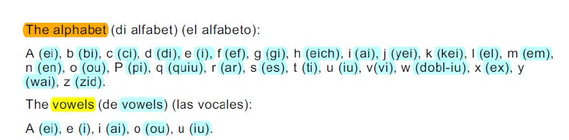

H -> (eich) // J -> (yei) // K -> (kei) // Q -> (quiu) // X -> (ex) // Y -> (wai) // Z -> (zid)

[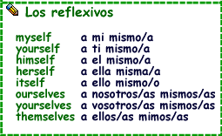](http://3.bp.blogspot.com/-OLBD5CYvV0U/T2M3kLU3wQI/AAAAAAAAAL8/GQP5YZAlhqU/s1600/chureflex.gif)

***Vocabulary***

**Supplies** -> suministros, municiones

**By the way** -> por cierto

**I’m afraid** -> me temo que

**Afraid** -> asustado, temeroso

**answering machine** -> contestador automatico

**No at all** -> en absoluto

**Neighbor** ->vecino, prójimo

**Not in traffic jams** -> No en atascos de tráfico

**Jams** -> enjambres, mermeladas

**Bet** -> apuesta, poner

**I bet you** -> te apuesto

**Attend** -> asistir

**Seldom** -> raramente, muy pocas veces

**Often** -> a menudo, con frecuencia

**Proofs** -> pruebas

**Bench** -> banco, tribunal, escaño

**Beside** -> junto a, al lado de, además de

**Habit** -> habito, costumbre, maña

**Entire** -> completo, todo, entero

**Mad** -> enojado, furioso, loco, demente